**Project Design Phase-I**

**Solution Architecture**

| Date | 19 September 2022 |
| --- | --- |
| Team ID | PNT2022TMID24963 |
| Project Name | Project -Nutrition assistant Application |
| Maximum Marks | 4 Marks |

**Solution Architecture:**

When it comes to diet tracker app development, there are several routes you can choose from in terms of functionality. There are all sorts of nutrition and diet mobile solutions with different features out there.

### CALORIE COUNTER APPS

Mobile solutions like Lose It and Lifesum mainly focus on helping users count consumed calories. Besides the calorie-counting feature, such applications often provide additional insights into the nutrient quality of different foods by analyzing ingredients.

### RECIPE APPLICATIONS

With recipe apps, users get to choose the best meals according to their food preferences and health and fitness goals. The main premise of these mobile products is to educate users on how to cook healthy meals.

Examples: Paprika, PlateJoy

### NICHE DIET TRACKING APPS

People with specific tastes or dietary preferences may benefit from referencing a diet tracking mobile solution. So if a user is vegetarian, suffers from diabetes, or bears a child — they can sort foods based on their individual circumstances.

Examples: HappyCow, Bump

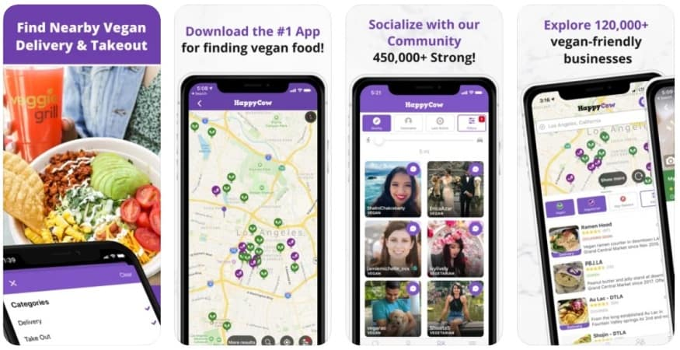

### FITNESS-FOCUSED APPLICATIONS

Some nutrition apps pivot strongly into tracking physical activity and exercises. Partly because healthy eating implies tracking not only consumed calories but spent ones too. Partly because having fitness lessons balanced against users’ eating habits in one product is super convenient.

Examples: Argus, SparkPeople

**Solution Architecture Diagram:**

